**Creative Computing with** 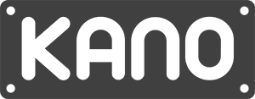

**Intro to Kano Code**

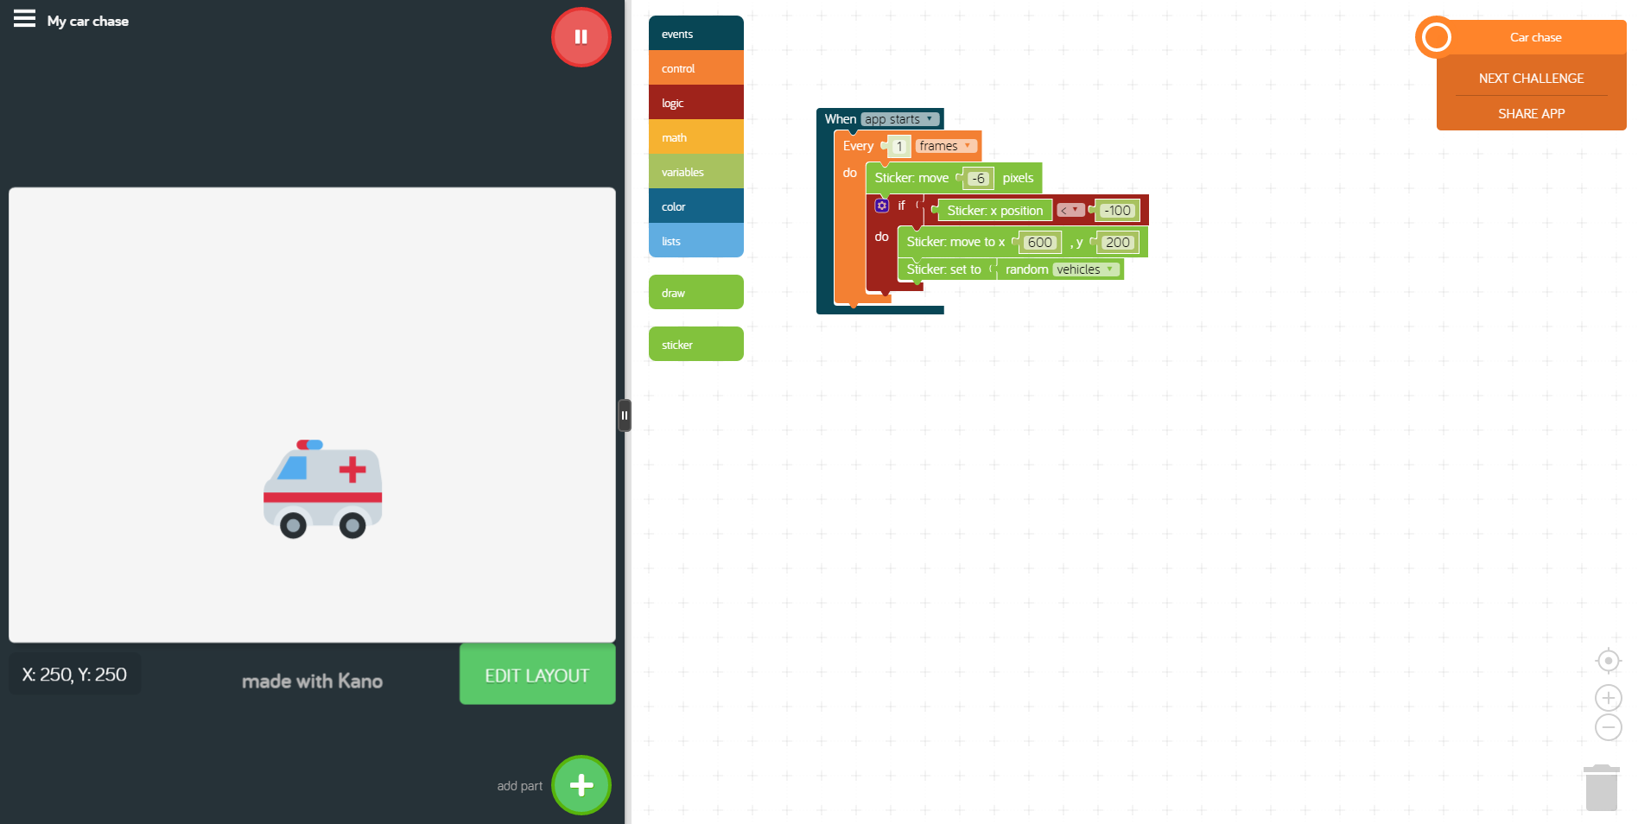

Have your creators gets used to Kano Code and begin creating unique creations to share!

|  |  |  |
| --- | --- | --- |
| **Title: Intro to Kano Code**  **Time: 1 hour 30 minutes**  **Level: Beginner** | | |
| Learning Objectives:   * Makers will understand how to access Kano Code * Makers will be able to identify the features of Kano Code and use them to create their own creations | | |
| * Use sequence, selection and repetition in programs: work with variables and various forms of input and output | | **Standards:**  **UK National Curriculum** |
| L1:6 CT Computational Thinking   * Understand and use the basic steps in algorithmic problem-solving * Develop a simple understanding of an algorithm * Understand the connection computer science and other fields   L1:6 CPP Computing Practice and Programming   * Construct a program as a set of step-by-step instructions to be acted out * Implement problem solutions using a block based visual programming language | | **Standards:**  **US Computer Science Teachers Association** |
| **Materials Needed:** world.kano.me | | |
| **Linking: (5 mins)**  Take 5 minutes to draw a picture of your favorite app and write 5 sentences explaining why it is your favorite app. If you need a refresher on what an app is check out this [link](http://www.bbc.co.uk/webwise/0/27488178).!  **Engage:** (5 minutes)  Have a few kids share out their favorite apps and why. Let students who have similar app love raise their hands or show their support for their app.  Apps are pretty awesome. From Angry Birds to Messenger, apps can do a lot of things. We are going to learn today about another feature of Kano called Kano Code . In this app we will learn how to use block codes to create apps and drawings that are fun, unique, and our own creations! | | |
| **Collect Kanos:** 5 min  **Retrieve Computers, Turn On, Log In..** | | |
| **Exploration Activities:**  **Challenge 0 A Walk Through of Kano Code**  Let’s get started! Click on Kano Code and open up an adventure:    You will be directed to the Kano Code page. At the top you will see a few options: Make, Project, and Community.   * “Make” will let you select Kano Code and open a new window to begin coding with no walk through instructions. It is like the playground option in MakeArt * “Project” will bring you to another page that will show you different projects you can code that will also provide a walk through. * “Community” is where you can look for users, user created creations, or check on the competition in Kano World.   Just to explore Kano Code, let’s open Kano Code from the “Make” link. When you open Kano Code you should see a screen like the one below.    Like in MakeArt,in Kano Code you have a side that is where you code and a side that is your canvas. In Kano Code our canvas is on the left and or coding area is on the right.  A few things about the display. On the left you have a blank canvas. Like in MakeArt, in Kano Code you can move your cursor around and on the bottom left you will notice and x and y number changing. This is to help you identify coordinates on the canvas and place objects as needed. You will also see “Edit Layout” and “Add Part.” Editing the layout allows you to change the background color of the canvas. The “Add Part” portion will let you add parts to the canvas that can make your app more interactive. You can add stickers, buttons, text, or other parts that interact with players.  The right side is our coding area. Kano Code uses block coding to make awesome creations. Below is a brief explanation of what blocks live in each button. For a more detailed explanation of each block refer to the this [document](https://docs.google.com/a/kano.me/document/d/1bFsvB0Mphz85oV14ur5O2gr94XoD4cSBUfEaFZN0KCU/edit?usp=sharing)  .    Under this button you will see blocks that tell your app how to respond. When _____ happens then you run the code that will connect in the blocks.    Under this button you will see blocks that tell your app how to act. Most of these blocks include loops or timed/controlled processes.    Under this button you will see logic blocks. These are: if, else if, else statements, comparison blocks, and boolean (true/false) blocks.  You can think of how you act in a scenario. If the store is open you go inside, else you leave. You do not break into the store if it is closed! Boolean blocks are the true false statements that help us determine what we should do in the scenario above.  If the store is true (open), then go inside. If it is false (closed) then leave.    Under this button you will see blocks that relate to math. These blocks include: operations, random selection, and comparison with numbers.    Under this button you will see blocks that work with variables. A variable is a placeholder for something, like how x and y are placeholders for a number in an algebra problem. However, variables in code can hold data, numbers, text, and other things.    Under this button you will see blocks that allow you to work with color in Kano Code. You can change the hue of a color, change a color, or select a random color.    Under this button you will see blocks that work with lists. A list is known as an array in programming and it is atoll you can use to help store a lot of information at once (like a box holding a lot of objects).    Under this block you can play with blocks that will let you draw a creation similar to MakeArt. You can draw different shapes, line strokes, and move about the canvas using coordinates to draw.  **Challenge 1:** Explore Kano Code! Open up Kano Code and explore the projects that are available. Finish at least 2 of the walk throughs to get use to it.  **Challenge 2:** Are your kids ready for a challenge? Have them open up the playground and attempt the following scenarios:  Scenario 1: Open up the project “Car Chase” and complete as the directions show. Now lets hack it! Can you change the stickers that show? Can you change the placement of the sticker on the canvas?  Scenario 2: Open the project “My Swiss Cheese” and complete as the directions show. Can you hack this project to make something different than cheese? Using similar blocks, change the draw, math, and color blocks to create a different “random” background.  **Challenge 3:** Create Your Own! Your students have played with Kano Code and hacked a few of the projects to create their own unique creations. Now lets see what they can do with less guidance! Give the kids 2 options to choose from:  Option 1: Pick another project from Kano Code and hack it to be something COMPLETELY different!  Option 2: Go into the playground and design your own project and build it from scratch!  When students are done, they will share their creations with the class.  **Save your work and share to Kano World!** | | |
| **Sharing: 15 min**  Use the remaining time in class to share what the students hacked or created on their own. Remind students to share their creations on Kano World!  **Evaluation:**  Ask students to find one partner and turn and talk to answer the following questions. What did everyone like about the creations? What was difficult? What is a new skill you learned that will help next time you use Kano Code .  **Closing:**  On a post it note that the educator passes out, have the students write one idea they have for next time to use Kano Code | | |
| **Kano Cleanup:** 5 min  **Power down and put away the Kanos** | | |